**DAILY ONLINE ACTIVITIES SUMMARY**

|  |  |  |  |  |  |  |  |
| --- | --- | --- | --- | --- | --- | --- | --- |
| **Date:** | **16-06-2020** | | | | **Name:** | **Varsha H Shetty** | |
| **Sem & Sec** | **8th sem B sec** | | | | **USN:** | **4AL16CS117** | |
| **Online Test Summary** | | | | | | | |
| **Subject** | | **BDA** | | | | | |
| **Max. Marks** | | **30** | | **Score** | | **24** | |
| **Certification Course Summary** | | | | | | | |
| **Course** | **Advanced AWS cloud formation** | | | | | | |
| **Certificate Provider** | | | **Aws** | **Duration** | | | **30 minutes** |
| **Coding Challenges** | | | | | | | |
| **Problem Statement- #Given a string input Count all lower case, upper case, digits, and special symbols** | | | | | | | |
| **Status: completed** | | | | | | | |
| **Uploaded the report in Github** | | | | **yes** | | | |
| **If yes Repository name** | | | | **Varsha-Shetty** | | | |
| **Uploaded the report in slack** | | | | **yes** | | | |

Online Test Details: (Attach the snapshot and briefly write the report for the same)

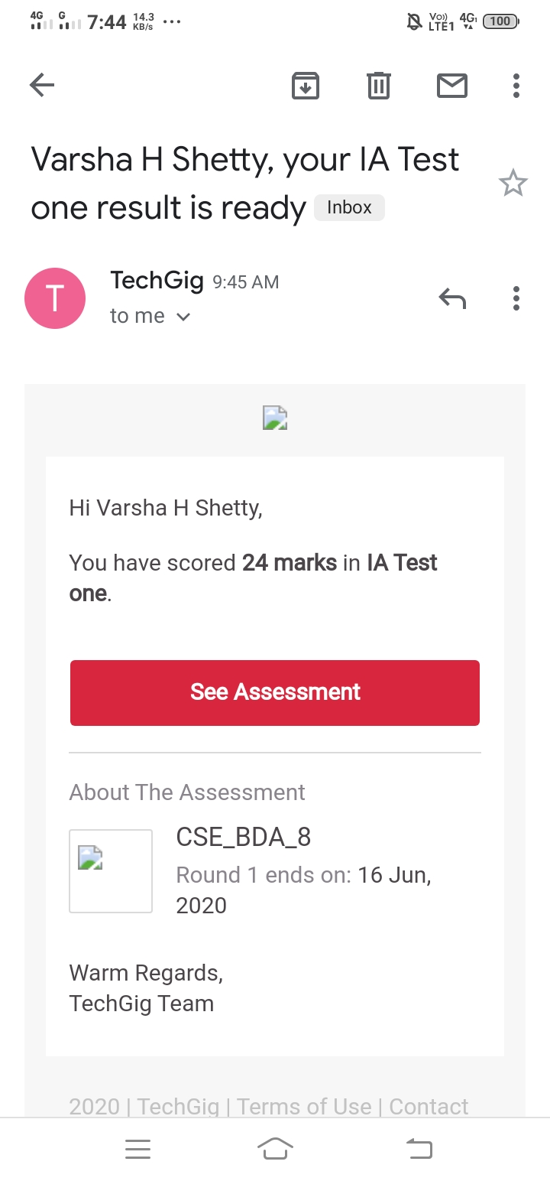

Certification Course Details: (Attach the snapshot and briefly write the report for the same)

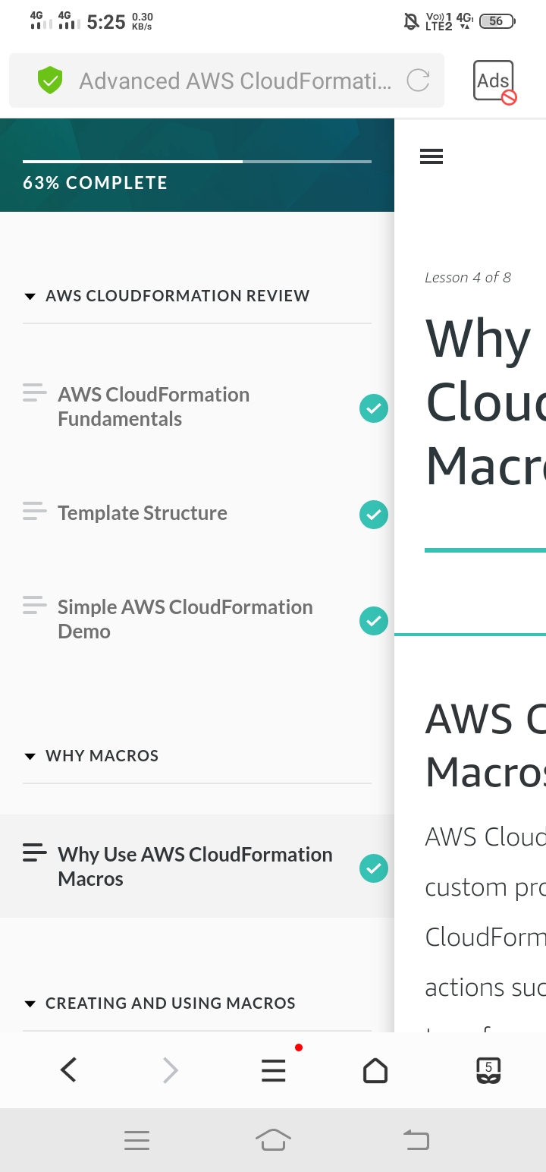

Coding Challenges Details: (Attach the snapshot and briefly write the report for the same)

Coding was given and it was uploaded for github and slack

**def findDigitsCharsSymbols(inputString):**

**words = inputString.split()**

**charCount = 0**

**digitCount = 0**

**symbolCount = 0**

**for char in inputString:**

**if char.islower() or char.isupper():**

**charCount+=1**

**elif char.isnumeric():**

**digitCount+=1**

**else:**

**symbolCount+=1**

**print("Chars = ", charCount, "Digits = ", digitCount, "Symbol = ", symbolCount)**

**inputString = "P@#yn2"**

**print("total counts of chars, digits,and symbols")**

**print(findDigitsCharsSymbols(inputString))**